Lauren Walter 2329033 - 3D Art and Animation

Intro

Recreating a retro style in a game is something that I’ve always wanted to do. After deciding on what kind of game we were going to make, a puzzle escape game with a slight horror theme, I took the opportunity to look at retro graphics and recreate the boxy, jittery style of old PlayStation 1 graphics. I enjoy horror in such a style as it allows for the enjoyment of the genre without being as gruesome and intense as horror games with realistic graphics. We decided to use the horror genre as a way to give the player urgency, a reason to escape, as the room around them begins to change and strange events occur which they want to get away with. These events would play through animations and audio I created.

My main influence for this style was from the game developer PuppetCombo, who creates retro horror titles as seen in the link below:

<https://www.youtube.com/watch?v=HEsUspaWfmc>

Process

My process started with collecting references for puzzles, art styles and themes for my group to look at and use as inspiration for the gameplay and mechanics. Games used for reference are the following titles:

RC Escape Rooms – The Curse of Amberly Manor

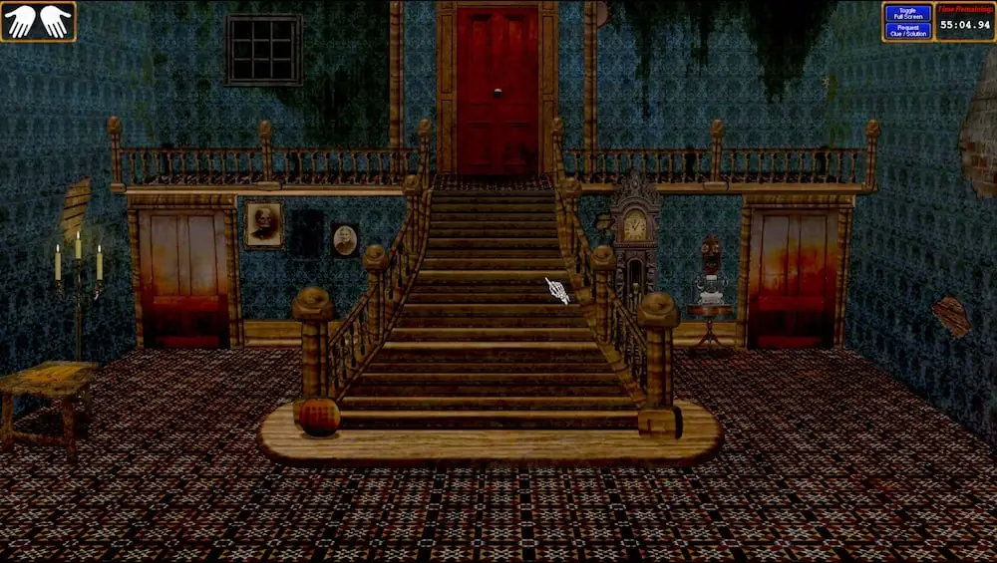

Using this title to look at point and click mechanics combined with older low poly models.

Cube Escape Collection by Rusty Lake

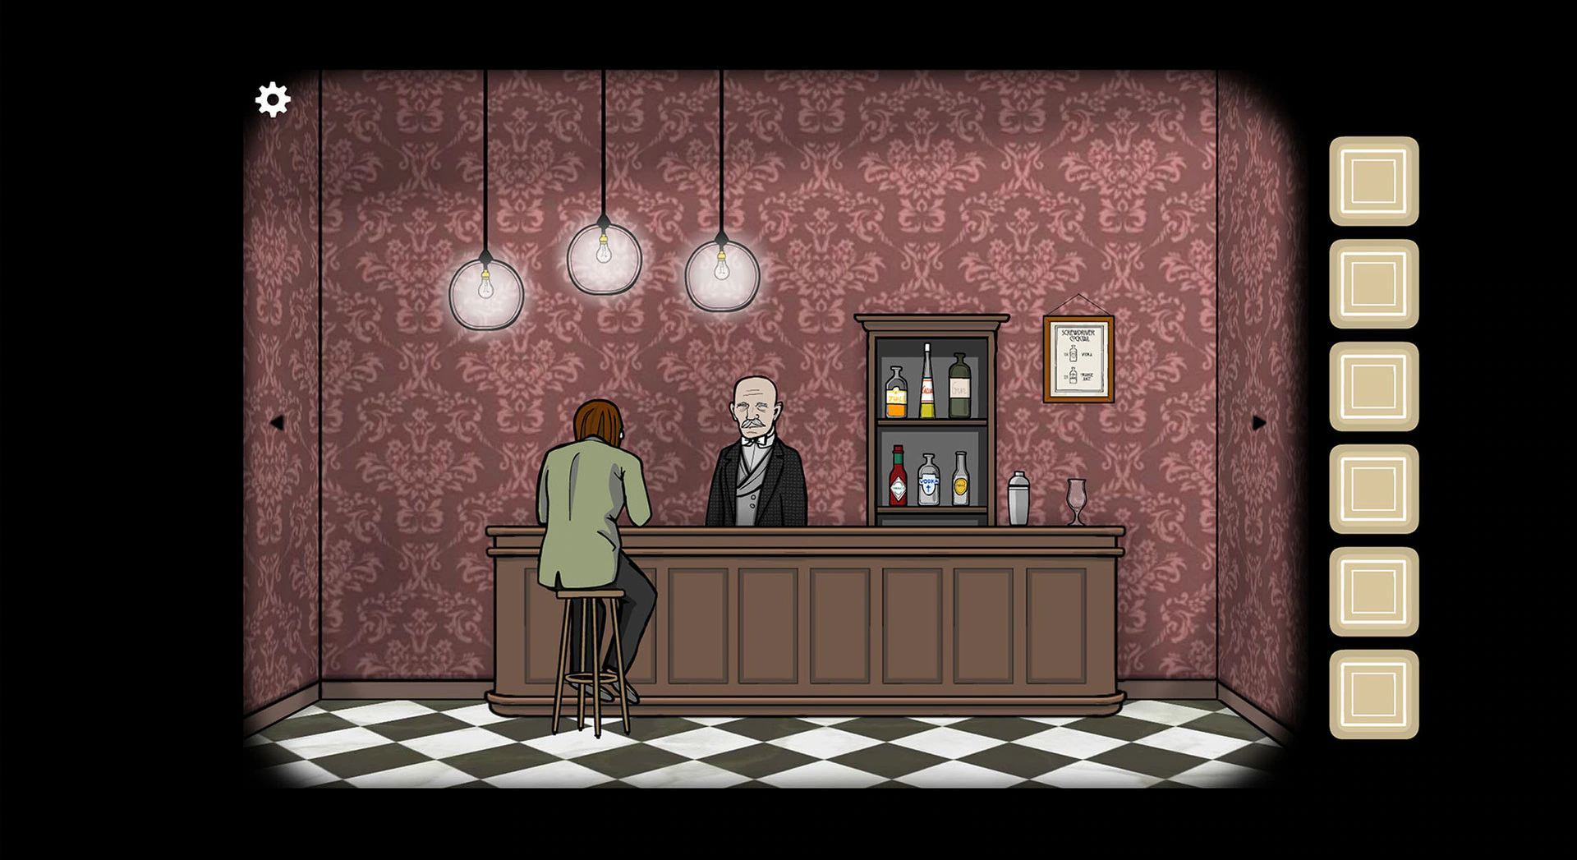

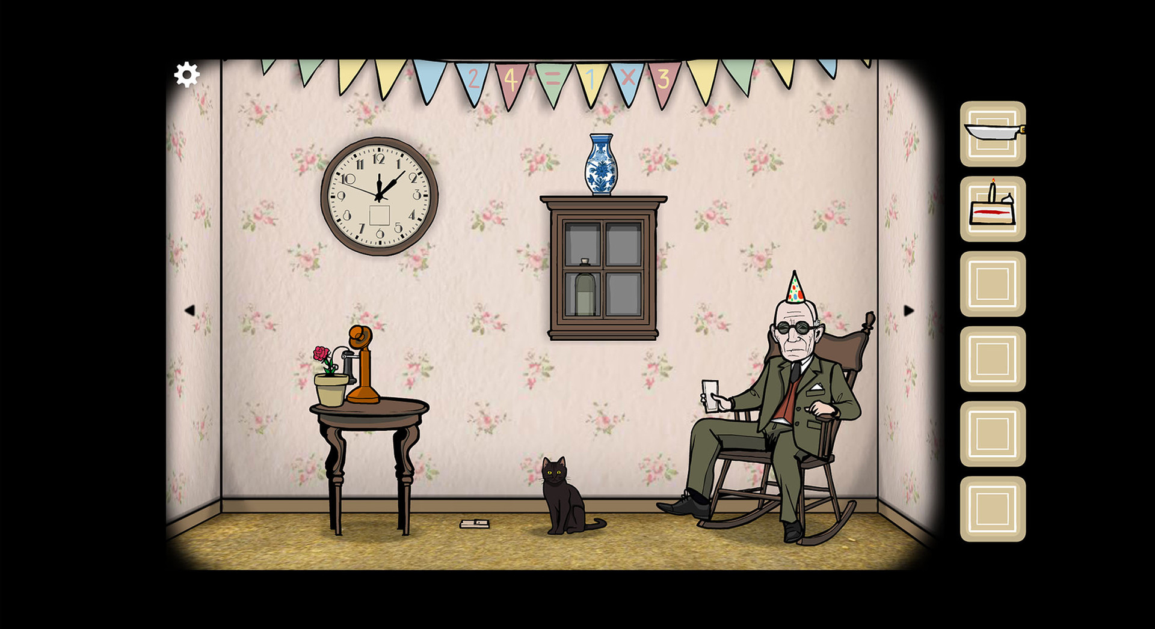

Using this game to look at eerie animations and themes and inventory systems.

Escape Impossible: Revenge by FunGamesMobile

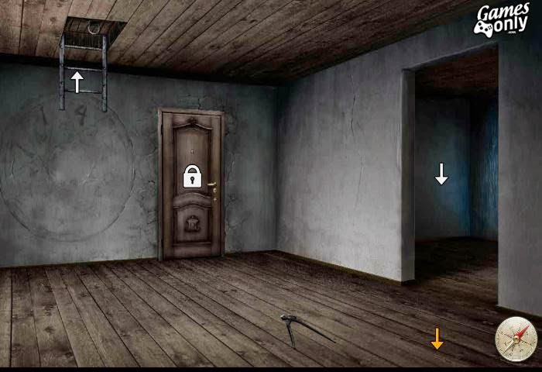

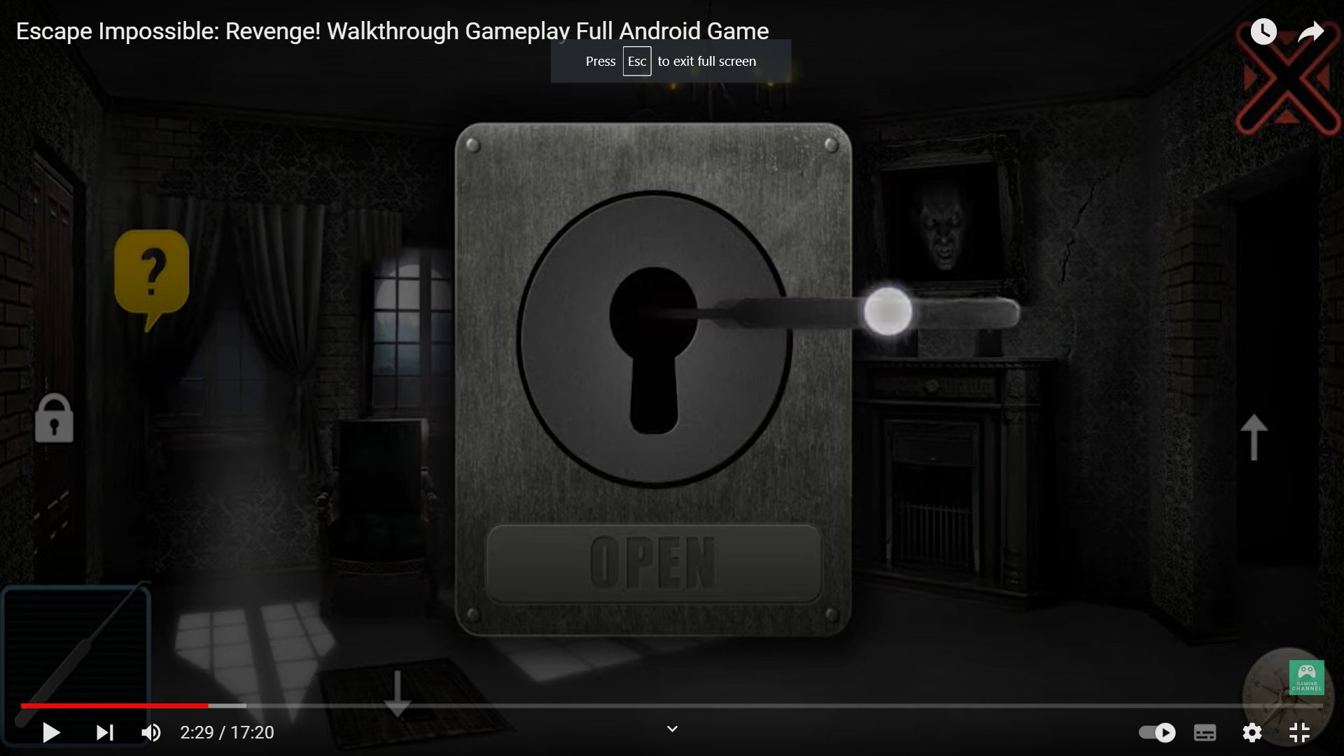

Using this game to look at puzzles which overlay the game scene, instead of zooming in on the puzzle in the scene like in the Cube Escape collection.

PuppetCombo Games

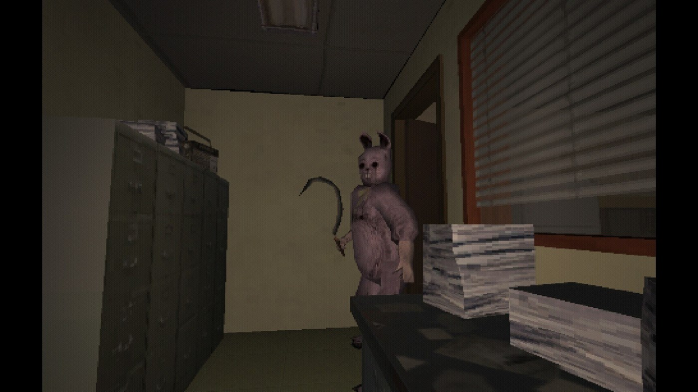

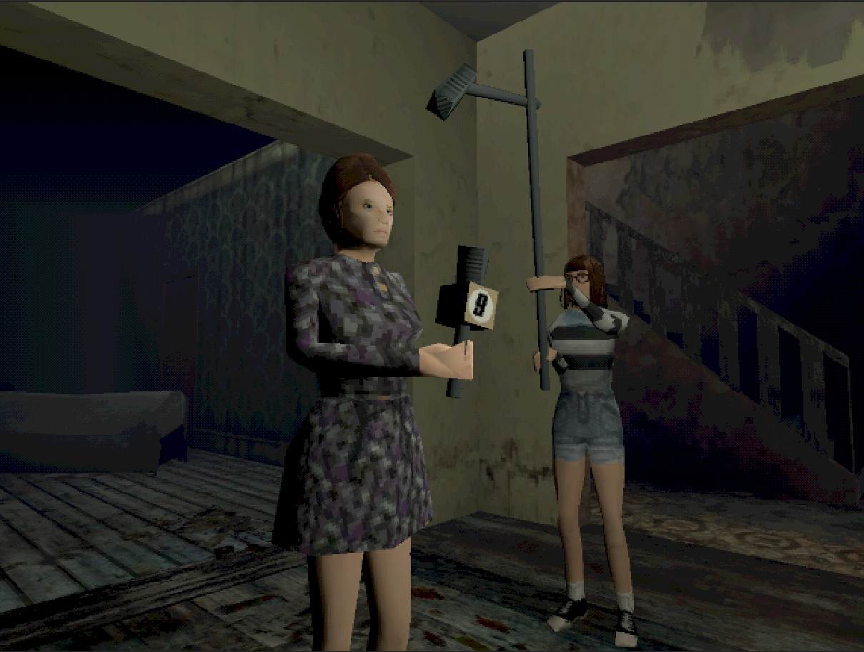

Using this game to look at modern games in Ps1 style graphics with low res textures, VCR effects and sound. A 80’s game horror aesthetic, a personal favourite of mine.

After deciding upon certain gameplay mechanics as a group I began creating a level layout and furniture assets to go into the scene.

Below is a rough layout of the level. Elements such as cabinets, fridge doors, blankets and curtains would need to be opened and closed when the player clicks on them.

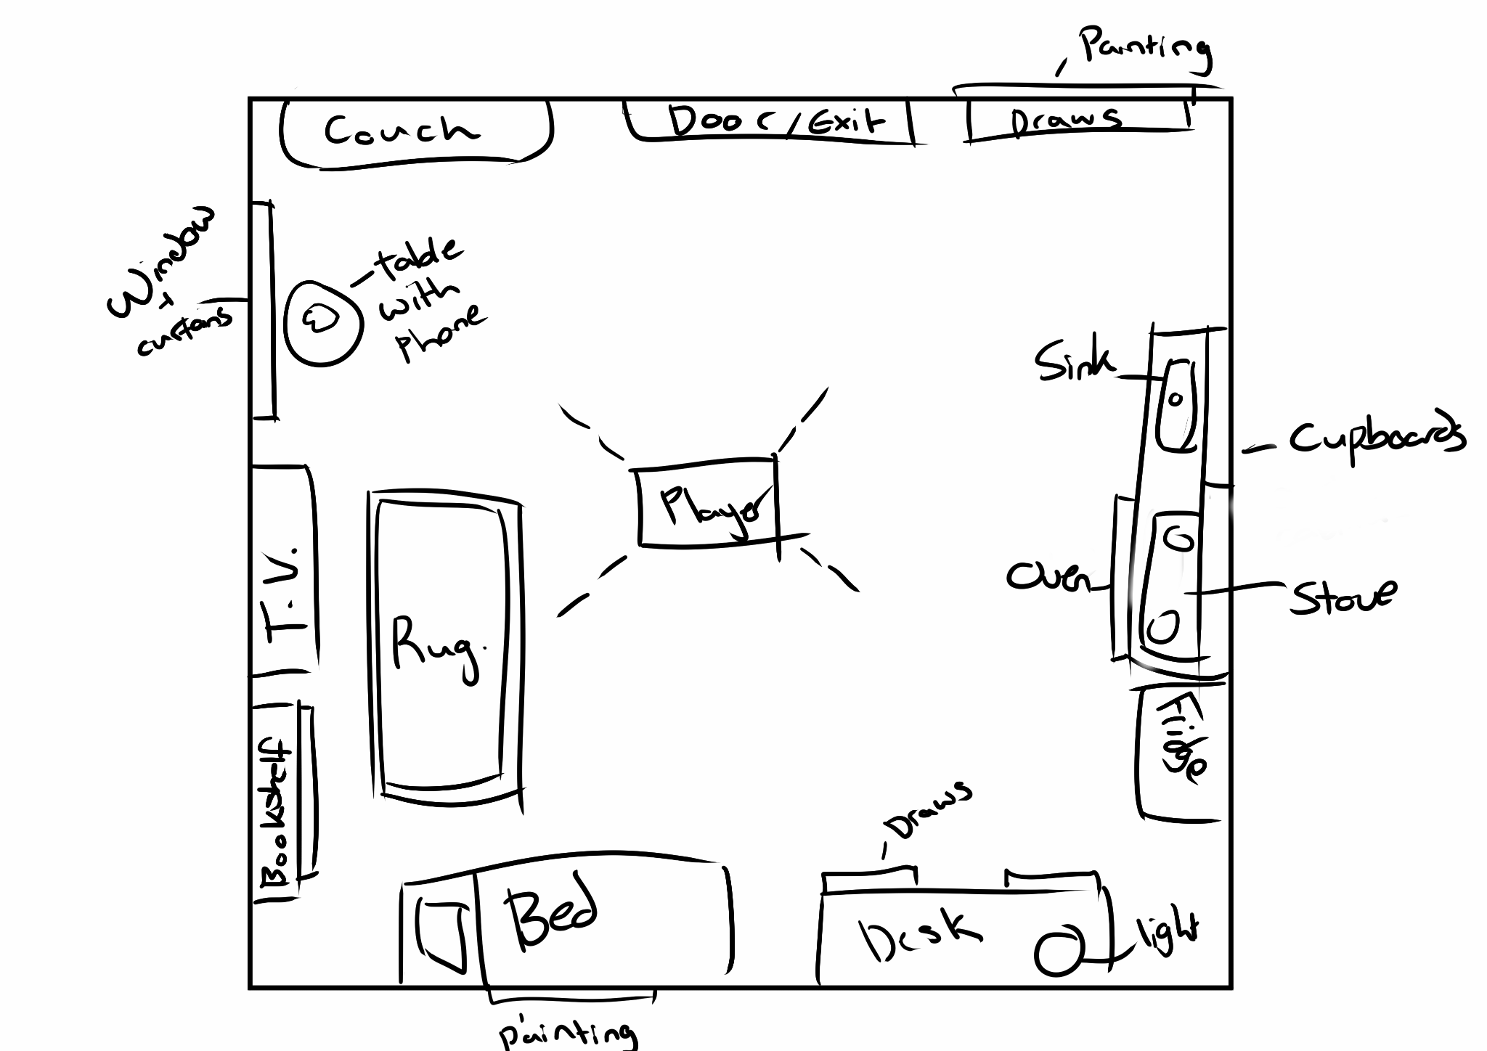

I later decided to exclude draws as the static camera that can only look at one wall at a time would hinder the visibility of items in the draws when opened.

I sourced a Unity shader that would allow me to create textures and materials in the PS1 style. The shader I decided to use was the URP-PSX shader by Kodrin on github.

<https://github.com/Kodrin/URP-PSX>

After adding the shader and learning how to implement and edit it I began working on the furniture assets needed in the room. I created the assets and edited their Albedo and UV maps in Blender before exporting them into unity and applying the URP-PSX shader.

The list of *furniture assets* and their animations include:

* Couch
* Bookshelf
* Desk
* Chair
* Kitchen Cabinets X4 - can open and close
* Sink and cabinets X2 - can open and close
* Oven
* Fridge
* Rug
* Bed and blanket
* Window and curtains - can open and close
* T.V. Set
* Brick phone
* Side table
* Painting X2
* Door - can open

Next I was given a list of *puzzle items* that were needed in the room:

* A box wrapped in plastic - plastic can be removed and box opened
* A box that needs a code - can be unlocked and opened
* Knife
* Fork
* Door Key
* Book - can be opened
* Bed sheet- can be pulled back

* I sourced external image textures to apply to the URP-PSX, all source references are listed at the end of this document.

Using a combination of DoTween and normal animations I created a Script that allowed for the opening/closing and required movement of the above assets. Puzzle items and the Door can be ‘lock’ through a boolean, allowing players only to open them (play the opening animation) when they use a specific item, such as a Key needed for the door.

I then created *Creepy Animations*. These were animated events that contributed to the horror and eerie aesthetics of the game and can be played when needed.

Creepy Animations include:

* The brick phone vibrating and ringing, then a audio of a woman and her child followed by the phone hanging up
* An audio of water running and blood appearing in the sink
* A figure appearing in the window and quickly moving away
* A painting suddenly falling
* The final animation is the *End Distortion* animation which is triggered when the player unlocks and opens the main door. Static audio begins to play and the scene becomes pixelated. The figure from the window stands in the doorway and comes towards the player. The pixelation increases until the player can’t see anything.

The pixelation effect was done by recording changes on the URP-PSX shaders Pixelation Controller script’s pixelation height and width fields.

*All audio was sourced from Freesound.org and referenced at the end of this document.

These animations are controlled by the Creepy Event Controller which has an optimised script that allows for the above animations to be called when required in other scripts. Some animations require additional checks to be made in other scripts for them to be effective. Such checks include not looking at the sink when the running water audio plays and the blood appears, and having the curtains open when the figure appears by the window.

Project screenshots

Each object's URP-PXS shader was edited to allow for the correct texture resolutions and vertix jittering effect during camera and object movement.

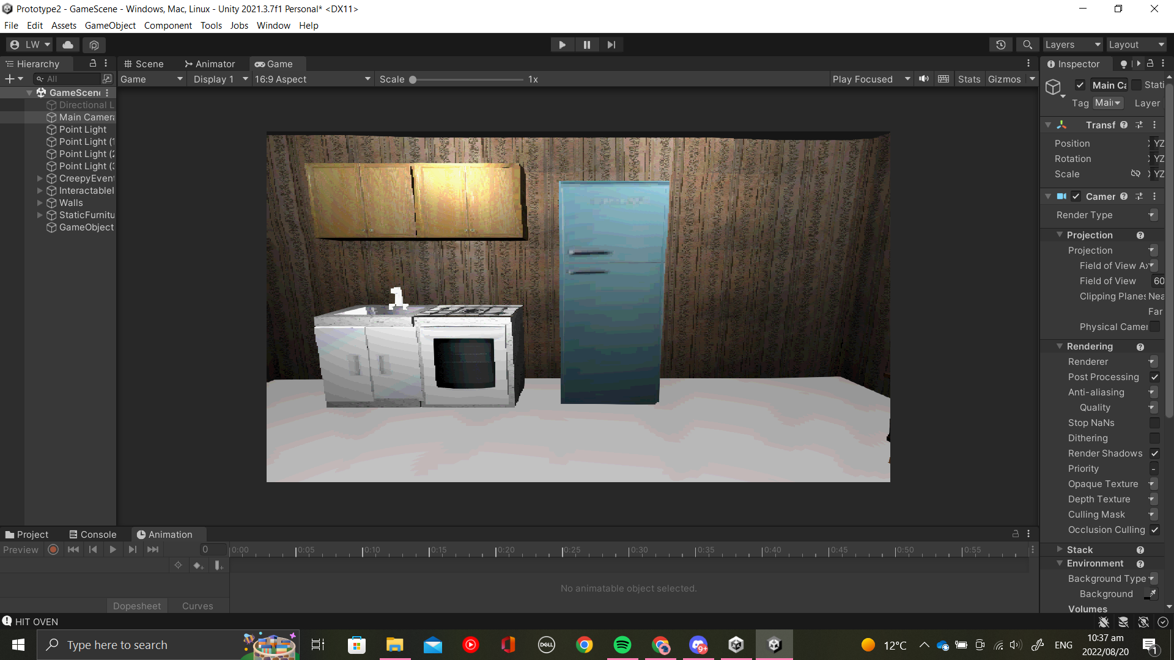Kitchen set closed

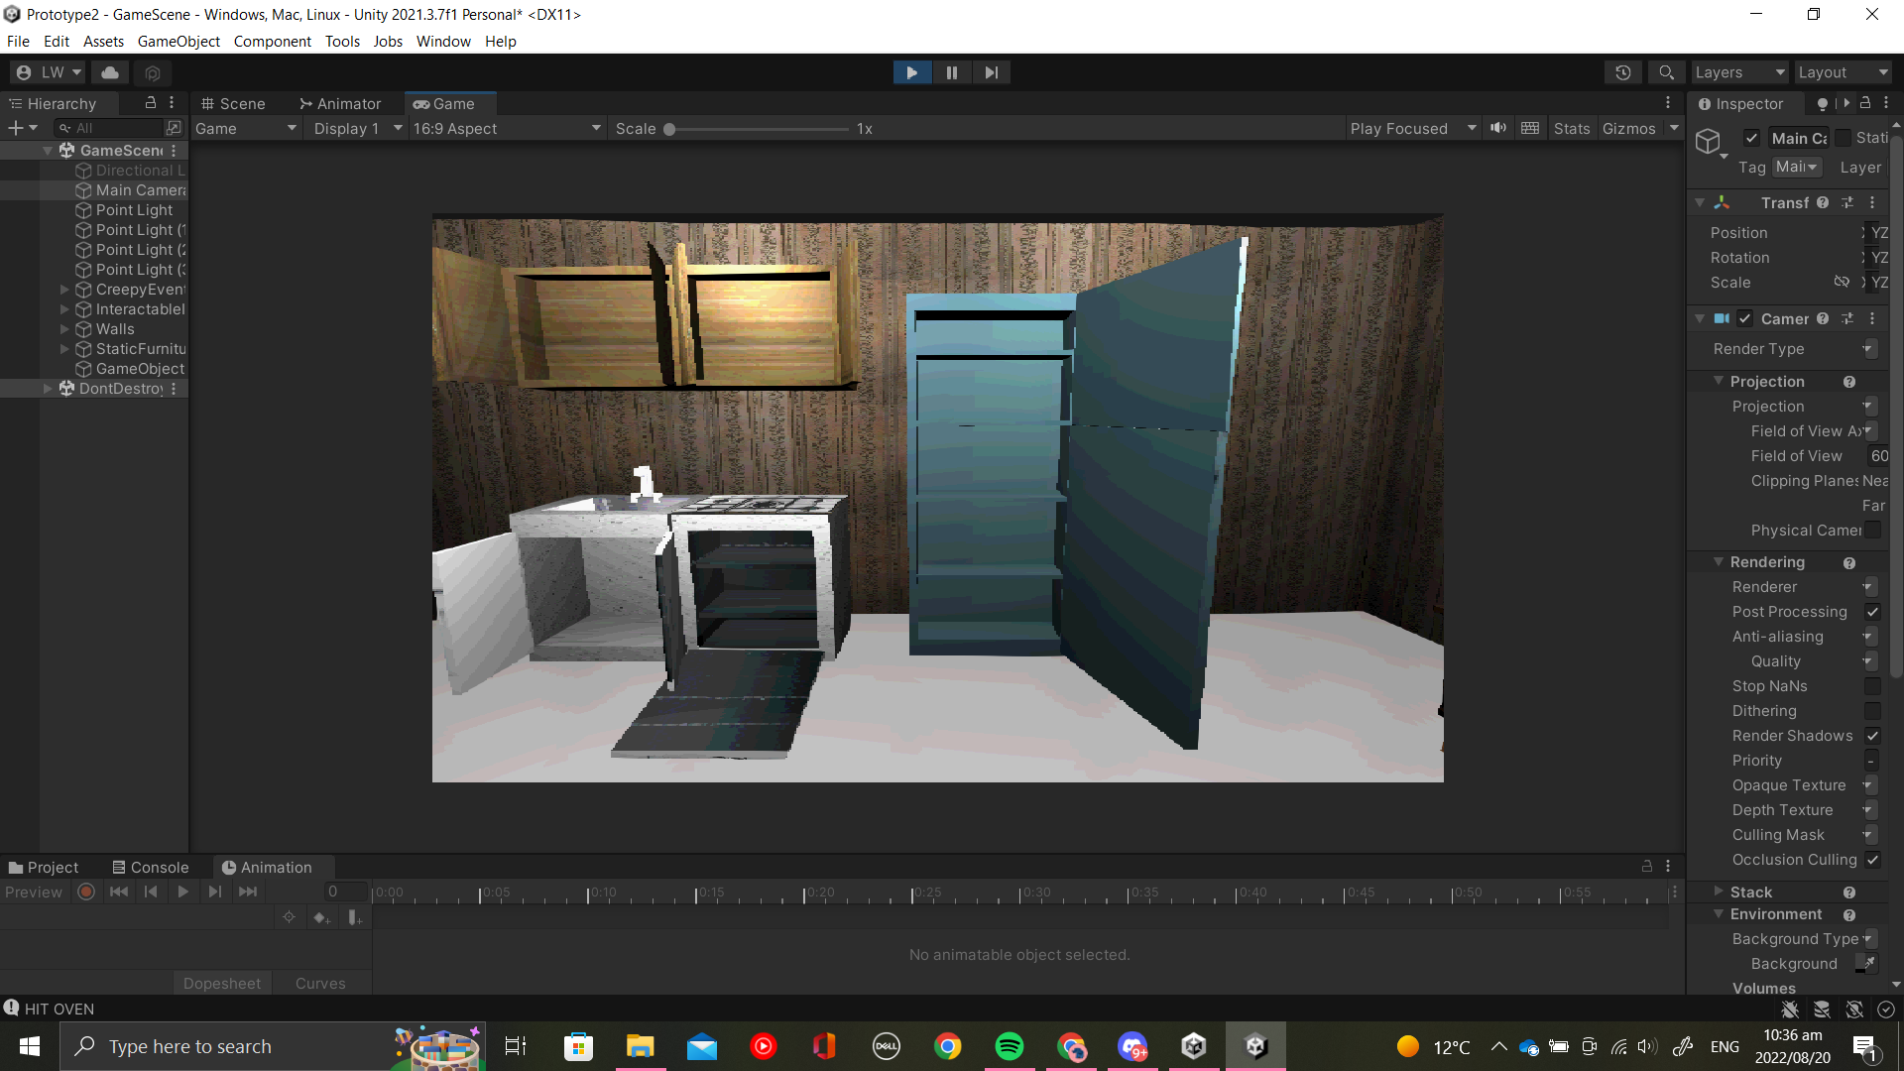Kitchen Set opened

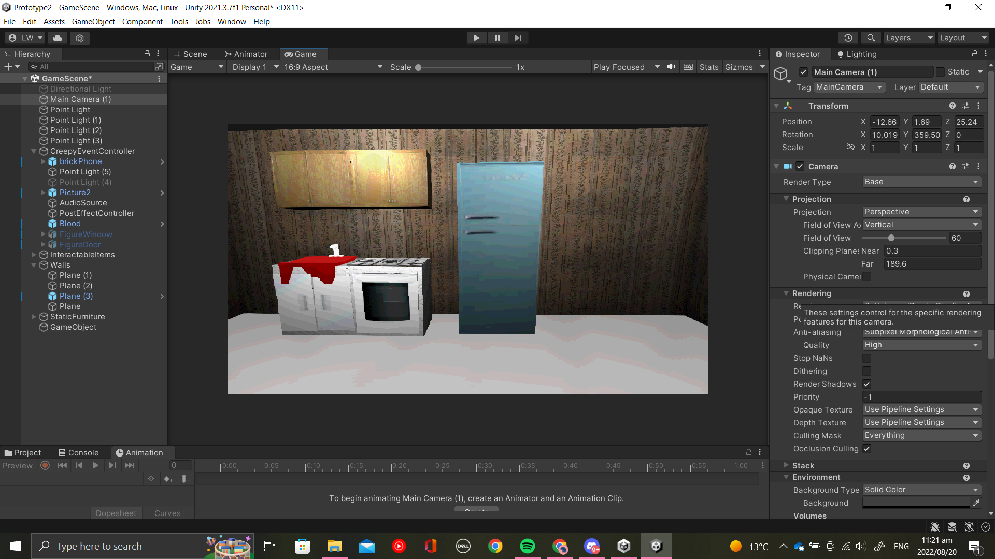Blood in sink

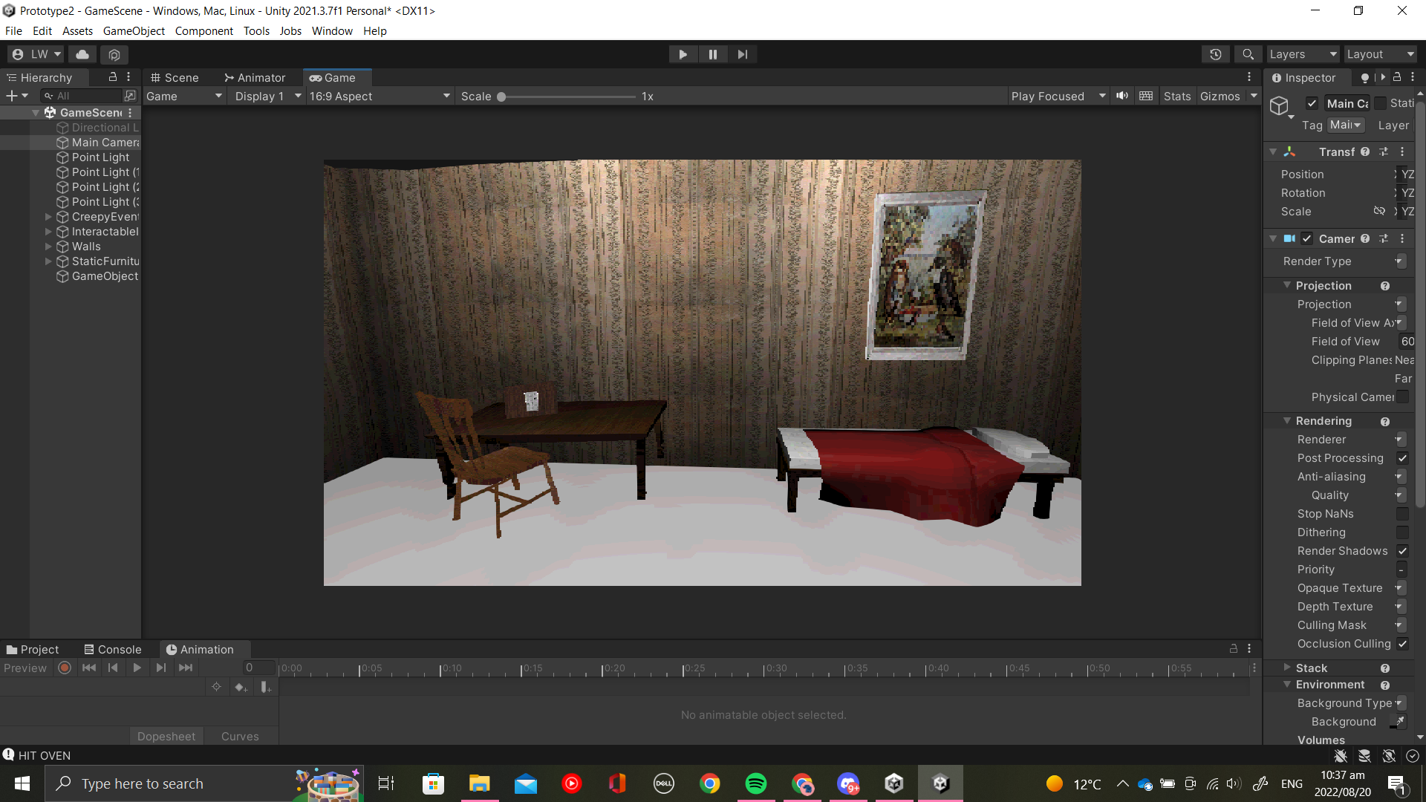Box with code on table

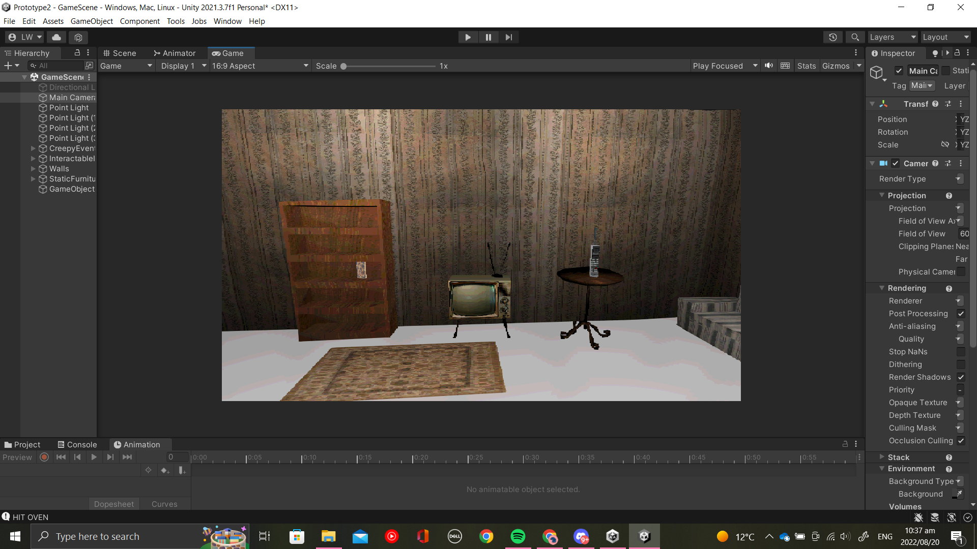Book that can open on shelf and phone on table

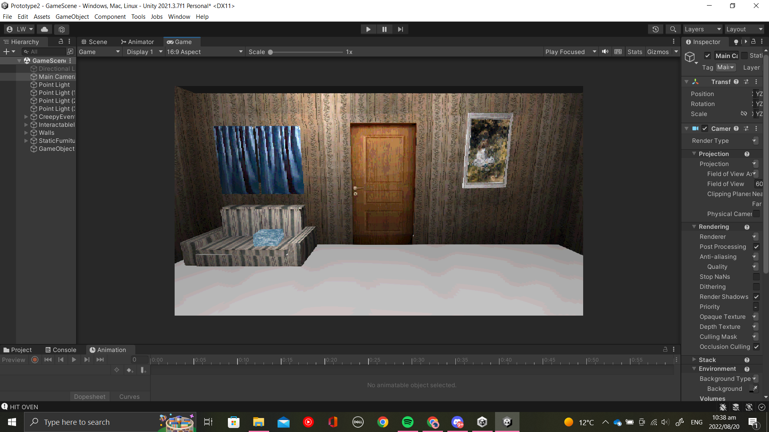

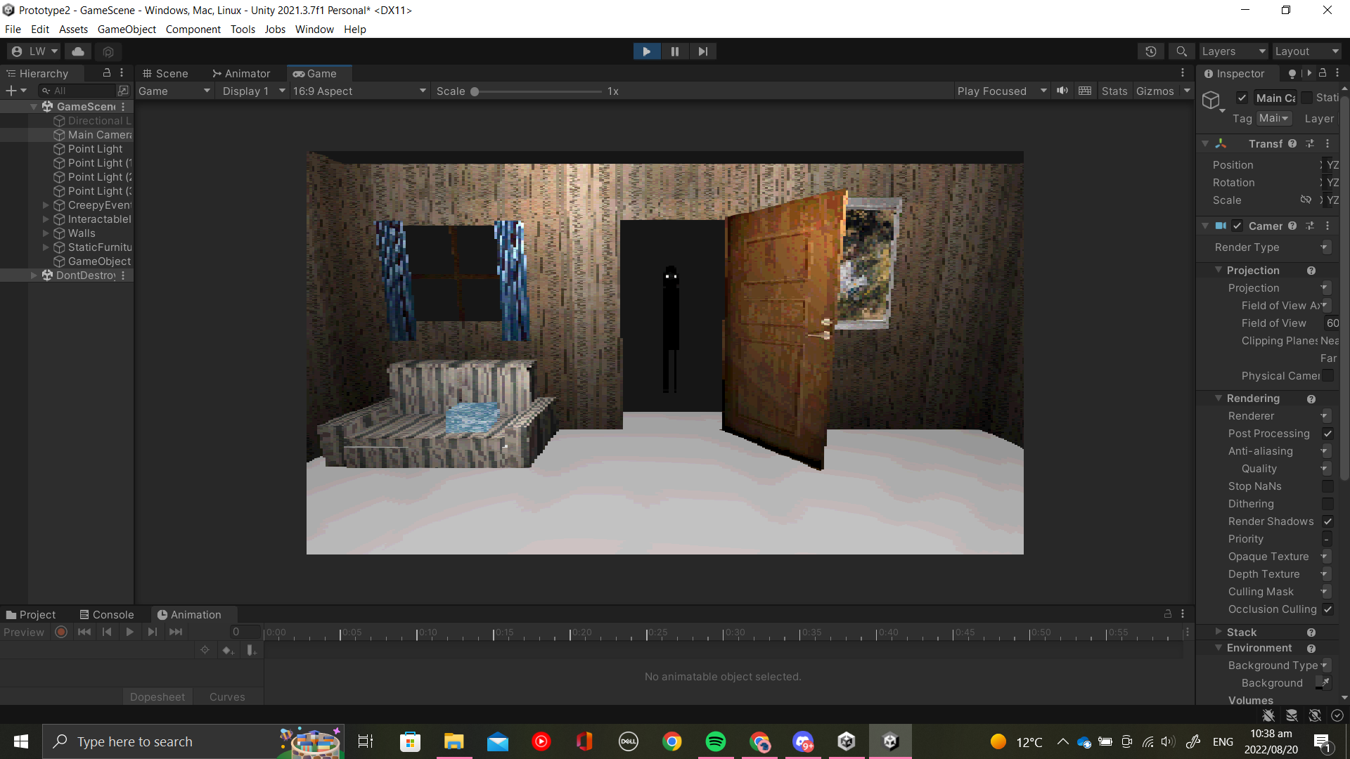Curtains opened figure in doorway

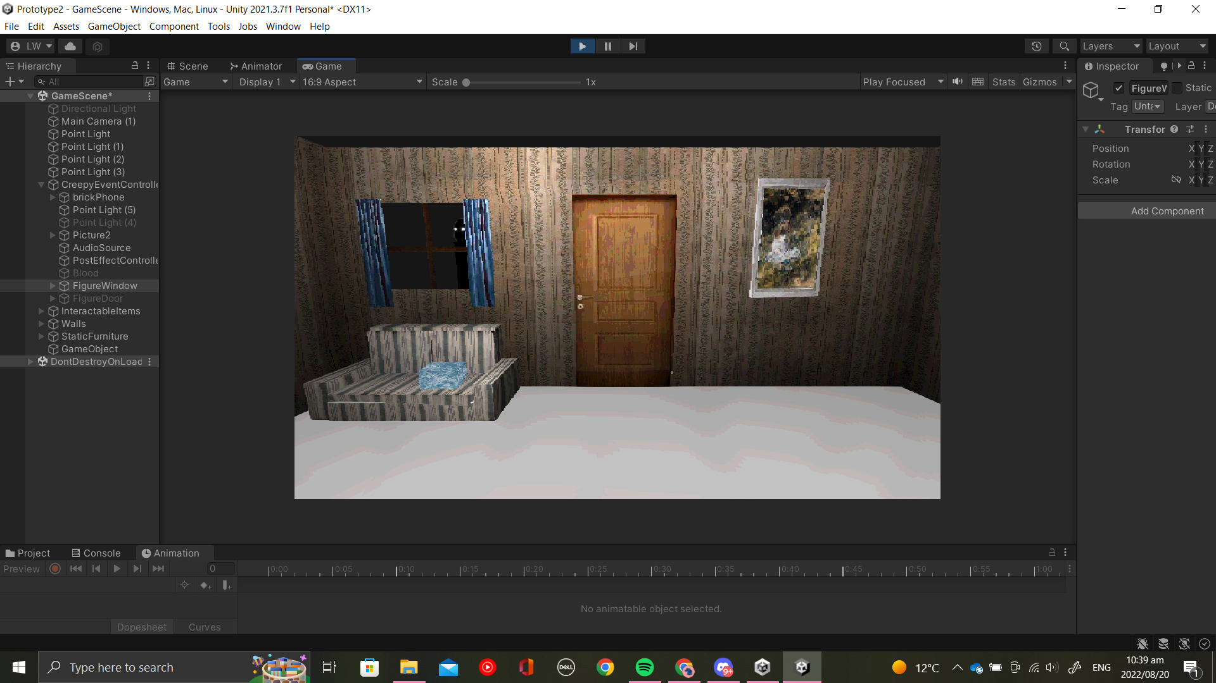Figure at window

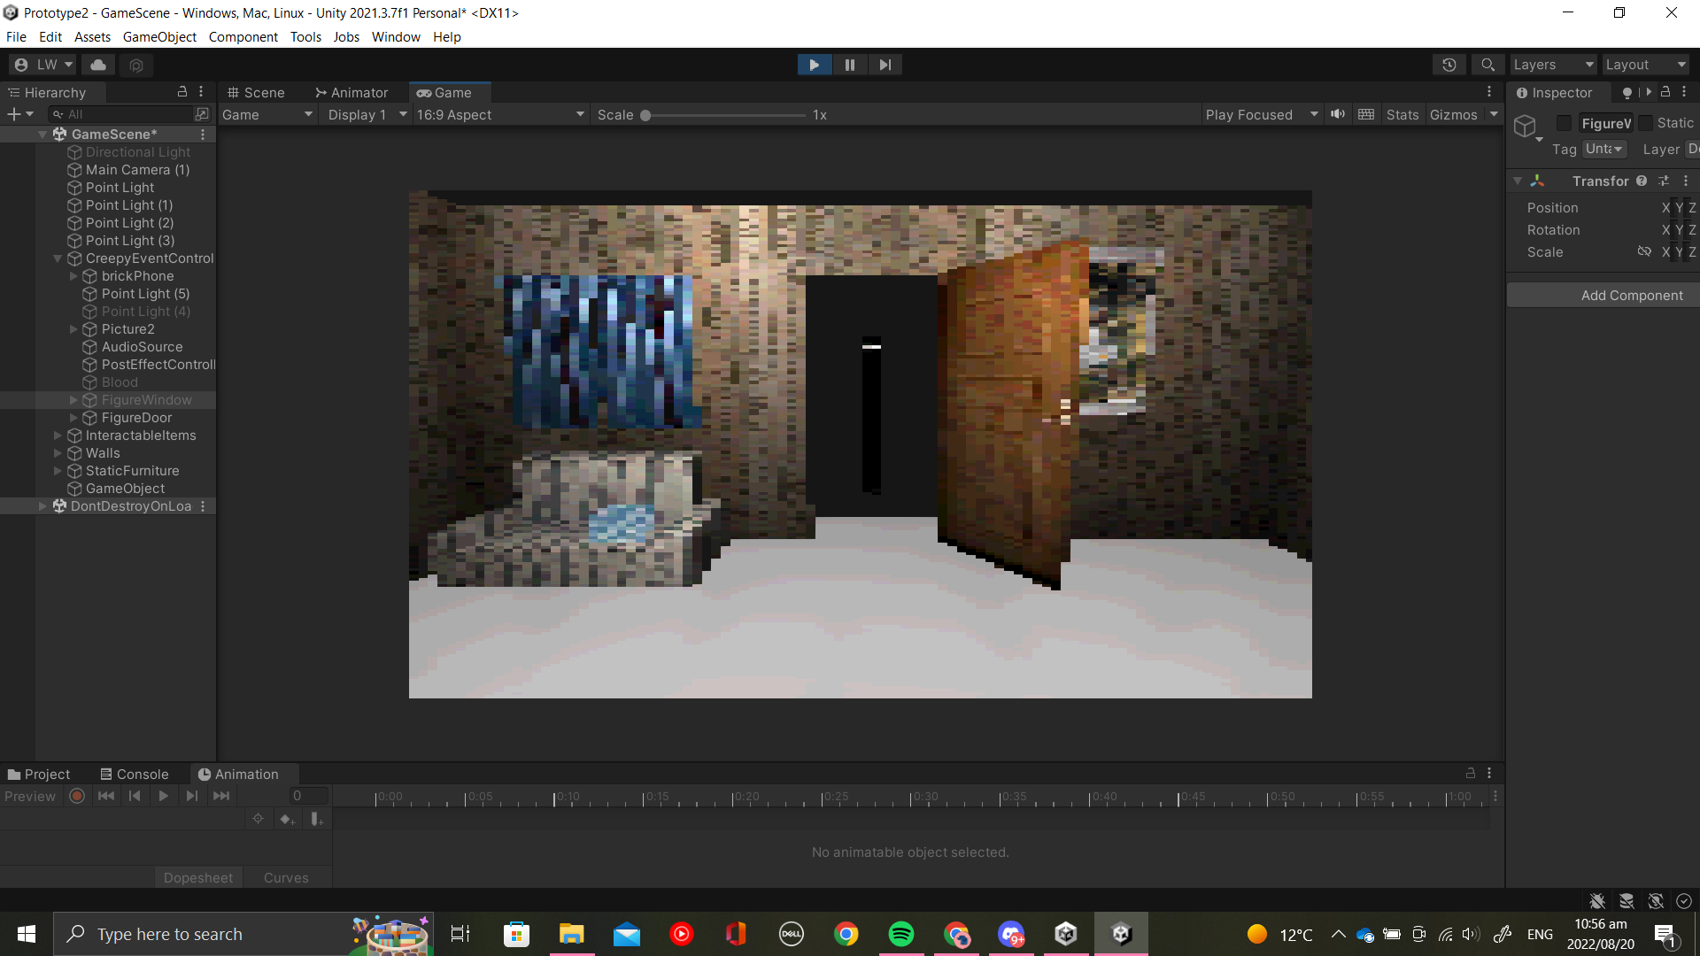Pixelation effect of end Distortion Animation

Reflection

Creating both the assets and animations for this prototype was a long and difficult process. I feel that I underestimated how much time would be required to learn how to use the URP-PSX shader and edit it until I got the effect I wanted. I had problems when using DOTween as the axis never correlated with the ones I wanted to move, hence I opted to use normal animations for items that didn't open on a vertical hinge, such as the oven, phone vibration and bed sheet, as struggling with DOTween was taking too much of my time. I would like to go back to it however and figure out why I was having so much difficulty with it as I have used it in projects before without any problems.

I enjoyed the challenge of keeping assets extremely low poly as I often wanted to add more detail in the mesh itself, however being restricted to more simple shapes and image textures for detail showed me ways to create good assets without having to sacrifice the games performance.I am very pleased with the game's aesthetic result and I am glad that I took this opportunity to try recreact a style that I’ve always wanted to on modern hardware.

References

Texture References:

"Floor Mat PNG Free Image" at https://www.pngall.com/floor-mat-png/download/57922 under Creative Commons

"1980's Brick Phone Image" by Brad Helmink

"Kitchen Cabinets image" from Second Life Marketplace at <https://marketplace.secondlife.com/p/Kitchen-Cabinets/3965512>

"Wood Door" by safakoguz on 123RF at <https://www.123rf.com/photo_10697487_wood-door.html?vti=ocmx8vb8laqiuwiy59-1-52>

"Curtain" by Noize Watch at <https://www.kindpng.com/imgv/hhmiTbx_curtain-hd-png-download/>

"24-inch freestanding gas" at <https://www.jcperreault.com/en/products/ge-cuisiniere-amovible-a-gaz-de-24-po-jcgas300dmww>

"Dark brown wood texture background with design space" by Jubjang at <https://www.rawpixel.com/image/4062441/photo-image-background-texture-wall>

"Bathroom Cartoon Transparent PNG" by Yndyhktwlg at <https://www.subpng.com/png-6ef077/>

"Grey And White Stripe Material 2-Seater Couch" image at <https://lifestyleatbalitrading.co.za/grey-and-white-stripe-material-2-seater-couch/>

"Bellini BG905X review" image at <https://www.choice.com.au/products/home-and-living/kitchen/cooktops/bellini-bg905x>

"Old TV" by RF Boogich on Getty Images

"Vintage decorative wall paper surface with a floral pattern from ancient texture of an old house interior - victorian background wallpaper" by donmer101 at <https://www.123rf.com/photo_149811810_vintage-decorative-wall-paper-surface-with-a-floral-pattern-from-ancient-texture-of-an-old-house-int.html>

"Wooden twin size single bed with red linen isolated on white background." Include clipping path. 3d render by Dima Moroz at <https://www.shutterstock.com/image-illustration/wooden-twin-size-single-bed-red-602871668>

"Quartz surface white for bathroom or kitchen countertop" By stevanzz at <https://stock.adobe.com/search?k=granite+countertop+texture&asset_id=329529115>

"Illustration of a metal ATM keyboard with numbers and buttons. For safe cash withdrawal - vector stock illustration" by FORGEM at <https://www.istockphoto.com/vector/illustration-of-a-metal-atm-keyboard-with-numbers-and-buttons-for-safe-cash-gm1320444868-407005383?phrase=number%20keypad>

TexturesCom_BookCovers0077_2_masked_S at textures.com

TexturesCom_Various0506_1_S at textures.com

TexturesCom_Plastic0144_1_S at textures.com

"Great Silver Brushed Metal Texture Background" at <https://www.freecreatives.com/textures/silver-texture.html>

"Dark Wood texture" by mutaaex at <https://www.deviantart.com/mutaaex/art/Dark-Wood-texture-280856160>

"Galanz - Retro 10 Cu. Ft Top Freezer Refrigerator - Blue" image at <https://www.bestbuy.com/site/galanz-retro-10-cu-ft-top-freezer-refrigerator-blue/6437997.p?skuId=6437997&intl=nosplash>

"Who killed cock robin?" by McGill Library at <https://unsplash.com/@mcgilllibrary>

"A Girl with Flowers on the Grass" by Maris at <https://unsplash.com/photos/VsnDYMWollM>

Audio References:

"Phone hang up/ suspend" by kyliank at <https://freesound.org/people/kyliank/sounds/178537/>

"HiDaddy.wav" by daveincamas at <https://freesound.org/people/daveincamas/sounds/31490/>

"synthesized telephone rings.flac" by Timbre at <https://freesound.org/people/Timbre/sounds/349187/>

"Accidental Noise, Zoom H6.wav" by InspectorJ (www.jshaw.co.uk) of Freesound.org

“Human body fall” by OptronTeam at <https://freesound.org/people/OptronTeam/sounds/553741/>

"OPENING THE TAP.wav" by taisssss at <https://freesound.org/people/taisssss/sounds/515584/>